

**Spectrum WASP Newsletter**

**June/July/August 2021**

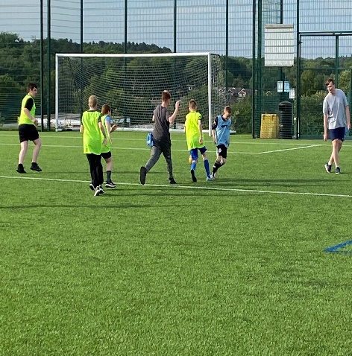 ‘SUMMER HOLIDAY’S 2021 … FUN IS ON THE WAY FOR ALL OUR SPECTRUM/WASP CHILDREN/YOUNG PEOPLE &FAMILIES...A LITTLE SOMETHING FOR EVERYONE...BRING ON THE SUNSHINE!

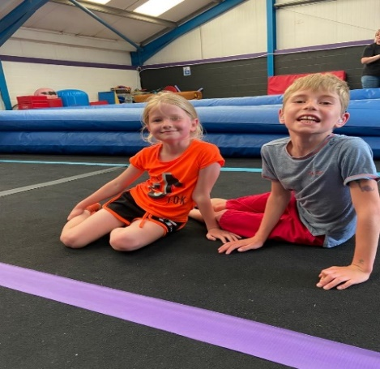We are so excited here at Spectrum/Wasp and looking forward to this year ‘Summer Sunshine Activities’, as Restrictions start to ease a little. We have some Super Activities for you ALL to get involved in, to have some ‘Summer Sunshine Fun’ with some of your favourite suggestions and ideas that you have put forward to us… so the ‘Wish Tree’ in Pine House has now started to bring in some of those ‘Wishes’…that you have popped on to it. Starting with Owen and wanting to do ‘Football’ sessions with Friends at Spectrum/Wasp…Well we have not only arranged a ‘Teen’s Club 11-18yrs Football Session, we have gone one step further and offered to ALL our Registered Children 9-18yrs a ‘Football Skills/Training’ Session’ over the next 7 weeks until July 20th, working alongside Mansfield Town Football Club, with ‘Football in the Community’, Thanks to Gary/Jordan and the Team there, this is now every Tuesday Evening, on the ‘Outdoor 3G Astro Turf Pitch’ at Joseph Whitaker Sports College from 6.00-7.00pm for All Boys/Girls to enjoy, which you are All welcome to come along too. We have also arranged that Day Trip for Families to the Beach? from the ‘Wish Tree’…A Ride for one of our Younger Children in a Land Rover Defender? it’s coming… and was it sleeping in a ‘Tent’ that you wanted? It’s on the way...’ So, keep those ‘Suggestions/Ideas and ‘Wishes’ coming through and here at Spectrum/Wasp we’ll see what we can DO ‘

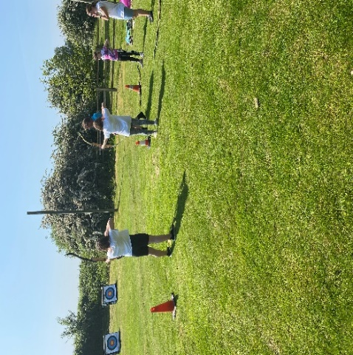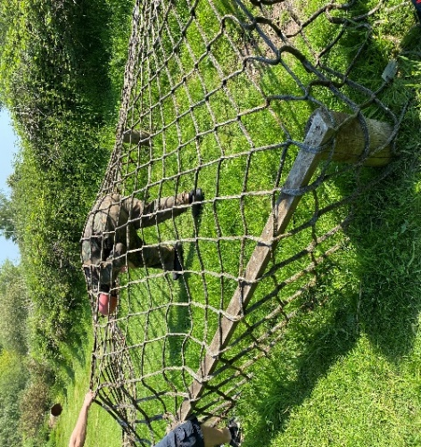

**What a “Sizzler” our June School Holidays” were**

**‘Thanks’ go out to Lockwell Hill Activity Centre with Simon/Team for the Outdoor Archery & Assault Course, what a ‘Great Time’ we All had…… Followed by Gymstarz Gymnastics with Gareth/Team on site @ Ransom Wood…Then onto Nathan/Team @ The Odeon Cinema Mansfield where AlI Families were invited along to the Autism Friendly Screening of the New Film ..’Tom & Jerry’…giving ‘Fantastic’ support to Spectrum/Wasp Children**

**PINE HOUSE IS STILL OPEN**

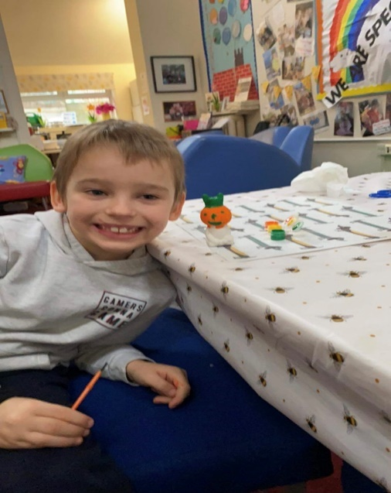Pine House Base -**Parent/Carer/Family Use** – **Free to use** Tuesday- Friday between 10am-5pm for one Family Household at a time to have ‘Family Time Out’ and ‘Home Schooling’ at our Wonderful base set in 70 Acres of Woodland - Please book your Morning/Afternoon/Weekend sessions in Advance as our base will need to be Deep Cleaned after every use by Emailing [info@spectrumwasp.org](mailto:info@spectrumwasp.org)

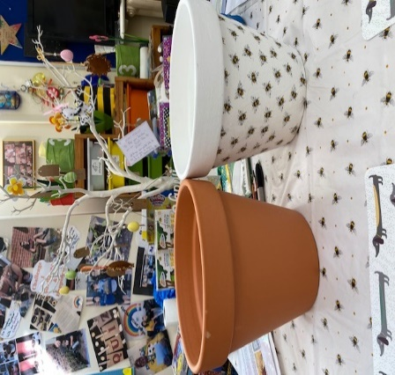**Support Worker**/Short Breaks Children/Young People for use Tuesday-Sunday - Please book your Morning/Afternoon/Weekend session in Advance, as our base will need to be Deep Cleaned after every use.

Enjoy Arts/Craft Materials… Woodland Nature Walk... Homework Catch up – Laptop/I-Pad/Eco Tank Colour Printer for your use with Home Schooling…Board Games ...Cake Baking Kits & Art Kits…TV/Netflix Films … OR Borrow our Spectrum WASP I-PAD with Parental/Carer Consent for Homework/School Work... Bring a Pack Lunch/Picnic to enjoy Outdoor at Pine House in the Woodland

We provide Hot/Cold Drinks/Snacks for you to enjoy to Prepare/Cook yourself at the Base for free!

**Cycle Hire @ Sherwood Pines**…

We have been Cycle active throughout last year 2020, and now from April 2021 with Our Spectrum/Wasp **Free** **Cycle Hire** we are back again @ Sherwood Pines Cycle’s... Dan and the Team there, have given us Amazing Support over the last year, helping to look after our Registered Families and making sure every Bike is Checked/Sanitised, also providing a Safety Helmet if needed, it has been just wonderful… So go down and enjoy ‘Family Time Out’ and say ‘Hello to Dan/Team’ who are doing a brilliant job for us…🚴🏻‍♂️...

We again have been able to offer this to all of our Registered Families and Support Workers with our Short Breaks Children Teens/Siblings through ‘Children in Need’ Funding and The National Lottery Community Fund, ‘**THANK YOU’** toeveryone who has, and is still giving us Fantastic Support to carry on with our ‘Family Activities’.

Enjoy a 1-hour Bike Ride Monday to Sunday at Sherwood Pines Cycle Shop on Site at the Pines. Children/Young People/Parents/Carers/Support Workers – No voucher needed for our **Spectrum WASP** **Registered Families**, head to Sherwood Pines Cycles and sign in on the Register with Dan & Staff... Enjoy the outdoor space on the Green Trail…**Parents/Carers** will take **Full Responsibility** for **ALL Children/Young People** while out on their Bikes. **No** Child/Young Person/Sibling is to Ride without Parent/Carer Support. (Cycle Shop is Open for Buying Cycles/Equipment/Maintenance/Service)

**How To Book Pine House A**

You will need to contact Sue or Jeni at [info@spectrumwasp.org](mailto:info@spectrumwasp.org) to book in ‘Our Diary’ your Morning/Afternoon or Weekend Session at Pine House for your ‘One Family Bubble’/Carer Session or for Support/Workers with Short Breaks (Respite Care) Children/Young Person’s wanting to use ‘Pine House A’ this will need to be booked in Advance in ‘Our Diary’…Thank You..

**Don’t forget to Keep ‘POSTING YOUR PHOTOS/VIDEOS’ to Sue and Jeni so that we can Share with everyone at Spectrum/Wasp on our Website and Facebook Page … This all goes towards supporting our Evidence for Funding and most of All.. ‘Keeps Us All in Touch’ with each other... Send them over to info@spectrumwasp.org.....See you All** **soon.**

**NOTE -: We can at present offer the Use of our Base at “Pine House’ throughout the Week (Tuesday-Friday) and at the Weekend.**

**Sue and Jeni are here to Support you in any way we can, just contact us…at info@spectrumwasp.org and we will get back to you.**

Spectrum WASP would like to say a BIG **Thank You** for the support that we have received from our Funders throughout the Coronavirus Pandemic (Covid-19). This has enabled us to

continue to work and “**Keep in Touch”** with all our Children/Young People/Siblings and Families during these very unprecedented times…Sue & Jeni…. Registered Children’s Charity No 1146664… [www.spectrumwasp.org](http://www.spectrumwasp.org)

**Dates for the Diary June/July/August 2021**

**JUNE 202****1**

**Monday June 21st /28th** – **Raggy-Rug Workshop/ with Kate (Parent**) **@ Coffee Morning this Monday@ 9.30-11.30am**… A little Taster Session over 2 Weeks @Coffee Morning to enjoy the Creative ART of ‘Rug Making’ through Recycled Cotton Tee/Shirts, or any type of Jersey Cotton that’s no longer needed at home, so let’s Recycle with Our Parent/Carers @ Pine House A, Ransom Wood. Where you can also Book a 1-1 Meeting ... if you would like to speak with Sue/Jeni or Victoria we can pop you into our Dairy for this Meeting.

**Tuesday June 22nd** – Our **Football Sessions for All Children between 9-18yrs** working with MFTC & Football in the Community. This is open to all our Registered Children/Young People & Siblings at Spectrum/Wasp to enjoy each Tuesday Evening until July 20th, which will cover 7 weekly sessions, to bring in Fun/Life/Learning skills for all. Meeting @ Joseph Whitaker Sports College, Warsop Lane, Mansfield, on the Outdoor 3G Astro Turf Pitch, at 4.45pm, to start prompt 6.00-7.00pm. Remember to wear Shin Pads, and Brings a Drinks Bottle..Georgia will be there to Meet/Greet you, All Parents are Welcome to support.. Contribution is £3.00 per week.

**Wednesday June 23rd** – Monthly Management Committee Meeting @ Pine House A, Ransom Wood, Mansfield. NG21 0HJ..Meeting for 6.45pm to start 7.00-8.30pm

**Friday June 25th - Teen Club 11-18yrs –** Out/About with ‘Bowling/Basket Meal @‘Mansfield Super Bowl’ Stockwell Gate, ..Meeting there for 4.45pm to start our Bowling Games @ 5.00-6.00pm followed by your Choice from the menu of a Hot Food Basket Meal/Juice for All Young People attending.. Please make sure your wear your own suitable rubber soled Trainers for Bowling, (due to guidelines there) Contribution for the session will be £5.00.**. Please Book your Place with us through info@spectrumwasp.org**

**Sunday June 27t**h – **RECYCLING COLLECTION** @ Pine House A, Ransom Wood, Mansfield. NG21 0HJ Please ask Family/Friends to Support… Drop off your RECYCLING between 9.30-11.30am… Help to Support Spectrum/Wasp Fundraising ..See you there… **‘**

**JULY 2021**

**Friday July 2nd – Teen Club 11-18yrs** ... It’s the Hired **‘BIG SCREEN OUTDOOR CINEMA SHOWING’ with Popcorn/Ice Cream of… ‘THE ITALIAN JOB’ with a ‘TWIST’**…Guess Who’s Coming to Ransom Wood Screening… ??? What a Treat you Teen’s are in For…With Our ‘Surprise Crew’…A Night to Remember for you All even our Parent/Carer/Volunteers … Let’s just Say ‘MM’ Clue ..? Where something if you want to, in RED/WHITE OR GREEN (Italian)…Meeting @ Pine House A for 5.45pm to start our OUTDOOR Screening in Ransom Wood Picnic Area @ 6.00pm… See you there (’Ci Vediamo li’ )…Contribution will be £3.00 per Young Person.

**Monday July 5th – ‘Decoupage’ Workshop with Victoria**, the Creative Art of Paper/Napkins on Plant Pots/Glass Jars, etc…finding your own Creativity, having a little ‘U’ time @ Coffee Morning, at Pine House A, Ransom Wood...Meeting 9.30-11.30am, ..Bring with you any Jars/Plant Pots/etc… and we will supply the Napkins/Materials…to Start you off…along with a Coffee/Tea/Biscuits…see you there…

**Friday July 9th ..Teen’s Club 11-18yrs ‘Pool/Pizza Night’** Out/About @ The Towers, Botany Ave, Mansfield, NG18 5NG. Meeting there @ 4.45pm to Start at 5.00-7.00pm. All equipment will be provided, also Pizza/Chips/Juice Drink to eat at 6pm. Contribution on the night will be £5.00.. Parent/Carers Welcome to Attend/Support. **Please Book your Place in Advance to come along ...**[**info@spectrumwasp.org**](mailto:info@spectrumwasp.org)

**Tuesday July 13th – Football tonight for All 9.18yrs @ Joseph Whitaker Sports College 6-7pm (See Diary Post June 22nd)**

**Wednesday July 14th– Monthly Management Committee Meeting @ Pine House A, Ransom Wood, Mansfield. NG21 0HJ..Meeting for 6.45pm to start 7.00-8.30pm..**

**Friday July 16th – ‘Teen Club 11-18yrs tonight will be a ‘Teen’s Football** Session’ for All As Requested by Owen, to enjoy Chilled Time-Out Together..Meeting @ Joseph Whitaker Sports College, Warsop Lane, Mansfield, on the Outdoor 3G Astro Turf Pitch @ 5.45pm, to start prompt at 6.00-7.00pm, …it would be good if we could have a friendly match just after 6.30pm with our Parents/Carers against our Teen’s, so bring along your Trainers and enjoy the night, Remember your Drinks Bottle, the Contribution will be £3.00

**Sunday July 18th …’’Family** **BIKE RIDE @ Sherwood Pine, Ollerton Rd, NG21 9JL** with Ray/Jeni … We can Hire/Bikes/Helmets for you from the Sherwood Cycle Hire on Site with Dan/Team or you can bring along you Own Bike/Helmet, we will be Meeting outside Sherwood Pines Café for 10.30am for our ‘Family Bike Ride’ to start at 11.00am.. Parent/Carers Welcome to Support on the Bike Ride, on the Green Route there … Please remember to bring your Drinks Bottle/ Picnic Snack for after if you would like to stay on for half an hour…Please Book your Family Place if you would like to come along **info@spectrumwasp.org** …This will be a **Free Session** to enjoy Bike Riding….

**Monday July 19th** – Last Coffee Morning before we break up for the Summer Holidays…(Starts back Monday September 6th).. Come along to have a Summer Holiday Catch Up /Chat with Friends from Spectrum/Wasp…Meeting 9.30-11.30am.. you can just Drop through anytime throughout the Coffee Morning session..@ Pine House A, Ransom Wood, .See you there.

**Wednesday July 21st** – ‘**New Parents/Carers Meeting through our Enquires’…**Each Month through May/June/July we have held a ‘New Parents/Carers’ Meeting, which is held in The Elements Suite within Ransom Hall, Ransom Wood, Mansfield, NG21 0HJ. Meeting there @ 6.45pm to start at 7.00-8.00pm..this is an invite only session due to following Government Guidelines/Numbers Allowed. For any New Parents/Carers not already Registered at Spectrum/Wasp and wanting to Book a Place, **Please contact** [**info@spectrumwasp.org**](mailto:info@spectrumwasp.org) **and leave your details and we will get back to you to Book your Family Place.**

**Friday July 23rd - ‘End of Summer Teen’s Club 11-18yrs’ with Our “ Off Road 4 x 4 Driving Experience Spectacular Event”** with Notts Road Events Team..What an Exciting time for our Teens,.. Yes we said we would Do it !! Just what you suggested to us!!.. We are all Meeting at Lockwell Hill Activity Centre, A617, Farnsfield, NG22 8JG. Meeting there for 4.45pm to start prompt at 5.00pm. This will be followed by a ‘Hot Food Choice Snack’ …We will be looking for Parent/Carers/Volunteers to support on the ‘’Experience” with each Group of 4 ‘Teens’ **…Contribution will be £5.00 per Young Person. Please Book your Place in Advance** [**info@spectrumwasp.org**](mailto:info@spectrumwasp.org) **- Limited Places**

**Sunday July 25th – ‘RECYCLING COLLECTION’, DROP OFF.. @ PINE HOUSE A, RANSOM WOOD BETWEEN 9.30-11.30am, Ask Family/Friends to Support our Fundraising…See you there**

**OUR SUMMER HOLIDAY ACTIVITIES WITH SPECTRUM/WASP For JULY/AUGUST 2021**

**JULY**

**Thursday July 29th** – Spectrum/Wasp Coach Trip for our ‘**Skegness Family Day Out**’ – We will be enjoying a ‘Family Day Out’ at the Beach with all the fun of Skegness for the Day, which lots of Children have missed over the last year. We have Booked a Skills Coach, and will be meeting at Pine House A, Ransom Wood, at 8.30am to leave for 8.45am prompt and returning on the Bus back for 4.00pm, Returning to Pine House A, for approx. 6.00pm. If you would like to Book a Family Place on the Bus, please send through a message to [info@spectrumwasp.org](mailto:info@spectrumwasp.org) with your details/ family numbers …the Contribution for the Day Out at Skegness will be £5.00 each per Child or Adult

AUGUST

**Tuesday August 3rd** – ‘ **Tour of Mansfield Town Football Club’** at The One Call Stadium, Quarry Lane, NG18 5DA, (requested by Liam/Brad) for All Children/Young People & Siblings 5-18yrs to enjoy the thrill of our very own Mansfield Town Football Club Tour for 60mins, seeing all areas, from Sitting in the Stands/Pitch/Changing Room/Running up the Tunnel etc, then onto having some Fun Football Activities on their 3G Training Pitch together, if you want to join in. We will be Meeting in the Main Entrance Car Park of MTFC at 9.45am for the Stadium Tour to Start prompt at 10.00-11.00am, then after we will have our Fun Football Activities...This will be a FREE Session to enjoy for all… Parents/Carers will need to support their Children/Young Person…Remember your Drinks Bottle/Trainers for the 3G..you can wear your own Football kits if you want too…Please Book Your Childs Place at [info@spectrumwasp.org](mailto:info@spectrumwasp.org)

**Wednesday August 4th** – “ **i-JUMP Trampolining Park** , with Trampolining Fun for All will open just for our Spectrum/Wasp Children/Young People & Siblings 5-18yrs, to enjoy an early session before the public go in. We will be Meeting there @ 8.45am to Start our Fun Session at 9.00-10.00am, Socks to jump in will be provided FREE there. All Parents/Carers will need to watch the Safety Video On -line at home before coming along on the day, a Disclaimer needs also to be filled in On-line so all Children/Young People are Registered on the i-Jump system, which we have to do every year…Please Book in Advance at [info@spectrumwasp.org](mailto:info@spectrumwasp.org) .. Remember your Drink Bottle, Suitable Clothing to Jump in, the Contribution will be £5.00 per Child/Young Person, our Parent/Carer are Welcome to support.

**Thursday August 5th** _ ‘Let’s Make a **“BUG BOX BUILDING**” to take home... and have a **‘BUG WALK/HUNT’**, Enjoy the **Climbing Wall** and maybe the **Zip Wire**, in the Fantastic Woodland at the Amazing ‘Adventure Zone’ @ Portland College, Nottingham Rd, NG18 4TJ.. Phill/Lee/ Instructors will be on hand to support Spectrum/Wasp Children/Young People and Siblings from age **7-10yrs** ..We will be Meeting at the Main Reception area @ 9.45am to start Activities prompt @ 10.00-12noon…Just as you enter Portland College you will see a turning on the left hand side where the Café is for Parking…and the Main Reception is on the right hand side just passed the centre roundabout, which is a 2min walk… Book on to Reserve your Childs Place as Limited Places at [info@spectrumwasp.org](mailto:info@spectrumwasp.org) ..Remember your Drinks Bottle

Contribution will be £5.00 per Child ..Wear Joggers/Suitable Footwear..Bring your Gloves.

AUGUST 2021

**Monday August 9th – Archery/Woodland Assault Course for All 7-18yrs Children/Young People/Siblings …**  @ Lockwell Hill Activity Centre, Kirklington Rd, A617, Farnsfield, NG22 8JG, with Simon/Team ..Meeting there @ 9.45am to start prompt at 10.00-12noon Wear Suitable Clothing/Footwear for the Assault Course, Remember your Gloves and Drinks Bottle… Contribution will be £5.00 per Child/Young Person. Parents Welcome to Attend/Support…. Limited Numbers on the day so you need to Book your Place in advance at [info@spectrumwasp.org](mailto:info@spectrumwasp.org)

**Tuesday August 10th** _ ‘Let’s Make a “**BUG BOX BUILDING”** to take home, .. and have a ‘**BUG WALK/HUNT’**, Enjoy the **Climbing Wall** **and maybe the Zip Wire**, in the Fantastic Woodland at the Amazing ‘Adventure Zone’ @ Portland College, Nottingham Rd, NG18 4TJ.. Phill/Lee/ Instructors will be on hand to support Spectrum/Wasp Young People and Siblings from age **11-18yrs** ..We will be Meeting at the Main Reception area @ 9.45am to start our Activities prompt @ 10.00-12noon…Just as you enter Portland College you will see a turning on the let hand side where the Café is for Parking, then the Main Reception is on the right hand side just passed the centre roundabout, which is a 2min walk… Book on to Reserve your Young Person/Siblings Place as Limited Places at [info@spectrumwasp.org](mailto:info@spectrumwasp.org)

Contribution will be £5.00 per Young Person/Sibling ..Wear Joggers/Suitable Footwear, bring your Gloves, Remember your Drinks Bottle.

**Tuesday August 17th - WATER SAFETY/ RESCUE & DROWNING PREVENTION’** Se**ssion to include Water Safety/Rescue Aids to Use to Hand, Beach Awareness/Flags/Safe Areas, Swimming in Waves, ….@Rebecca Adlington Swim Centre, Westdale Lane, Mansfield, NG19 7BZ…With Qualified Swimming Instructors.. For ALL Children/Young People/Siblings @ Spectrum/Wasp .. For our 5-18yrs..Meeting there @10.45am for our session to start prompt @ 11.00-12.00noon .. Please bring along a ‘Long Sleeved Top/PJ Trousers’ to Swim in ….Contribution on the day is £3.00 per Child/Young Person, ALL Parents/Carers are FREE who are wanting to support the Child/Young Person in the Warm Training Pool. Book your Places in advance at** [**info@spectrumwasp.org**](mailto:info@spectrumwasp.org)

**Wednesday August 18th - FAMILY FUN SWIMMING SESSION’** **.@Rebecca Adlington Swim Centre, Westdale Lane Mansfield, NG19 7BZ….. For ALL Spectrum/Wasp Children/Young People/Siblings and Families... For our 5-18yrs..Meeting there @10.45am for our session to start prompt @ 11.00-12noon. Contribution on the day is £3.00 per Child/Young Person, ALL Parents/Carers are FREE who are wanting to support the Child/Young Person in the Warm Training Pool. Book your Places in advance at** [**info@spectrumwasp.org**](mailto:info@spectrumwasp.org)

**Thursday August 19th -** Family Visit to the **Odeon Cinema** Mansfield - **Autism Friendly** Showing For ALL ..To see the **Screening of ‘CROODS 2**’…For ALL Children/Young People/Siblings Parents/Carers…We are always so excited to be going to the Cinema! We will be having our OWN SCREENING for Spectrum/Wasp Families to enjoy Safely following updated Guidelines …Meeting there @ 9.15am for the Film to start Prompt @ 9.30am Child/Young Persons Contribution is £5.00 ..Parents/Carers are Free .. Please remember your Drinks Bottle/Snack to enjoy…Book your Family Place/Numbers attending through [info@spectrumwasp.org](mailto:info@spectrumwasp.org)

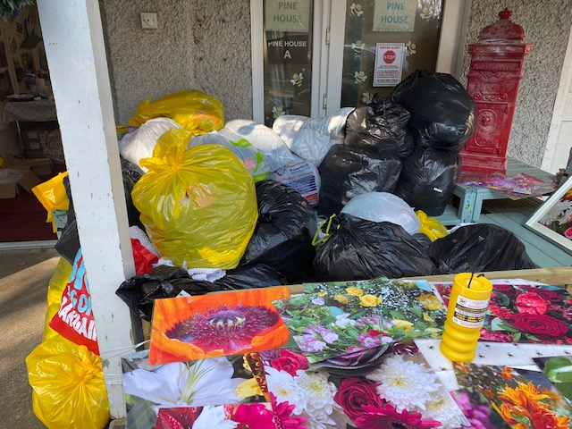**Sunday JUNE 27th … “RECYCLING COLLECTION” Drop Off at Pine House A, Ransom Wood, NG21 0HJ…9.30 – 11.30am…. Ask Family/Friends to supprt, if you need any of our Spectrum/Wasp Large Yellow Recycling Bags …we have them in Pine House for you to Collect from us or we can Post out if that helps….**



**IN MAY 2021 WE RAISED TOGETHER - £126.00**

**GUIDELINES - FOR ACTIVITIES FOLLOWING GOVERNMENT GUIDELINES**

**Note: - All our Activities will be following Government Guidelines/Social Distancing which can change on a day-to-day basis. Some Activities may be limited in numbers due to Guidelines, which will require Parents/Carers/Support Workers to prebook/ in advance via… info@spectrumwasp.org**

**ALL Activities are ‘Weather Permitting’ and we will be “KEEPING IN TOUCH” with our Registered Families by our Message Bird Text Service.**

**UP - COMING RECYCLING DATES – June 27th, July 25th, September 19th**

**FAMILY DAY OUT AT YORKSHIRE WILDLIFE PARK WITH A FAMILY OVERNIGHT STAY AT ‘THE DUKERIES RETREAT’..’FAMILY GLAMPING’**

**Thursday August 12th – Friday 13th – Enjoying a Family Day out at Yorkshire Wildlife Park, seeing the arrival this year of the NEW Polar Bear and her Cubs, along with all the other exciting Animals, then to enjoy a relaxed.. OVER NIGHT RESIDENTIAL STAY at Hill Crest Farm, Barnby Moor, Retford, DN22 8QS, just (15mins away from Yorkshire Wild Life Park) at ‘The Dukeries Retreat’ (Just opened this year all brand new)..in a Fun Family Glamping Bell Tent, with Amazing Facilities, on site for All Children/Young People/Siblings/Families to enjoy.. where we will have a wonderful relaxing stay with lots of exciting facilities for our Children to enjoy together, before going home the next day… Families will be sent their Holiday information Packs beforehand, so that we will have Spectrum/Wasp Families Meeting before going on our Residential Break Away. Enclosed is your INVITE, … Please let us know if you would like a Family Place via…** [**info@spectrumwasp.org**](mailto:info@spectrumwasp.org)

**“WISHING ALL OUR CHILDREN/YOUNG PEOPLE AND SIBLINGS A WONDERFUL SUMMER HOLIDAYS, ENJOY YOUR SCHOOL BREAK WITH LOTS OF SUNSHINE AND FUN AND WE WILL See you ALL after the Break in September”…**