Autism Awareness Week
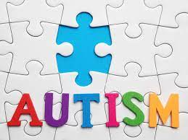

Would you like to join Rufford with their 7s quiz – A quiz with the Autism Awareness Theme of 7

Below is the answer sheet.

Rufford 7s Quiz:
Circle
Circle o or highlight the answer you think is correct:

Lloyd’s Car Quiz

1 | GT 3RS | GT2 RS
2 | Aventador SVJ 2109 | Aventador SV Roadster
3 | GT2 RS | Turbo S
4 | Lamborghini Urus | Lamborghini Aventador SV Roadster
5 | SV Autobiography | Defender
6 | Mercedes-AMG G63 | Benz Logo
7 | Mercedes-AMG GT R | Mercedes AMG R
Number 7 Footballers

1 | Manchester Utd | Manchester City
2 | French | Dutch
3 | David Beckham | Harry Kane
4 | Chelsea | Crystal Palace
5 | Nikkita Parris | Rachel Daly
6 | Four | Three
7 | How many goals?
Rufford Garden

1 | Halloween | Christmas
2 | Strawberries | Pears
Seb’s Tractor Trivia

1 | Red/ blue | Green/ yellow
2 | A | B
3 | A | B
4 | Front | Back
5 | A | B
6 | A | B
7 | A | B
Random Sevens

1 | July | August
2 | G g | H h
3 | Basher | Doc
4 | Reach for the Stars | 5-6-7-8
5 | 7 geese a laying | 7 swans a swimming
6 | 7 | 10
7 | 17 | 19.00
 | Total

