

**Spectrum WASP Newsletter**

**April/May/June 2021**

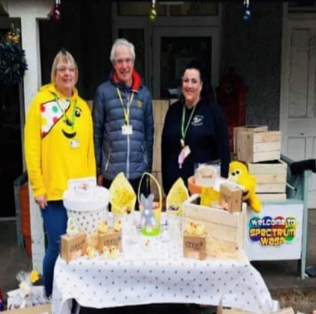

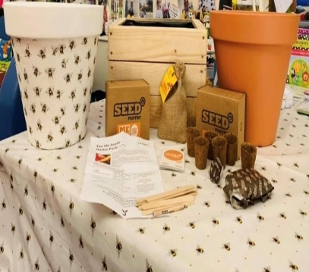JUST LOOK WHAT A ‘CRACKING EASTER’ We’ve ALL Had at SPECTRUM/WASP…....…. We are so excited here at Spectrum/Wasp to be looking forward to planning this year’s Adventures now as Lockdown Restrictions start to ease a little… Over the last two weeks while you have been off school, we have just had such a great time getting Out/About together with our Easter Activities, it’s been so wonderful to catch up and see so many of you, while on our FAMILY BIKE RIDE over at Sherwood Pines, then onto having such a Fabulous time at The ADVENTURE ZONE at Portland College, with Orienteering, Wall Climbing, Zip Wire, and the Amazing Woodland with all it has to offer with an abundance of ‘Fun’…IT’S BEEN JUST PERFECT .. We thought you would like to see some of the Photos that were taken on the day (Below). Our Volunteer’s Ian, James and Susan also came along to give out Easter Treats on Good Friday to All the Children/Young People/Siblings from over 50 Families who on the day collected their next ‘Challenge’ from our Base@ Pine House with our ‘Seed, Sow, Grow’, of Cress, Sweetcorn, Sunflowers, Pumpkins, Bee Bombs Wildflowers/Planters/Pots for All Children to enjoy and Decorate their own Pots/Planters, while on their Easter Holidays. We hope to be Sharing some wonderful news soon through our Activity Programme, Teen’s Club, and going Out/About…

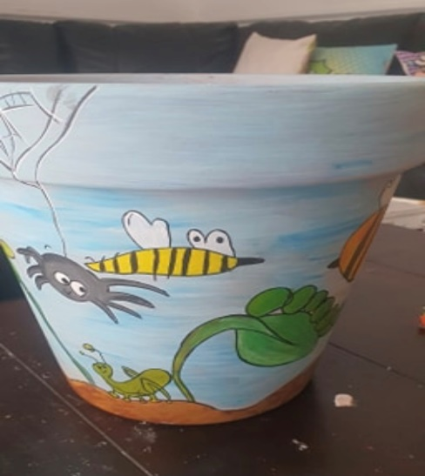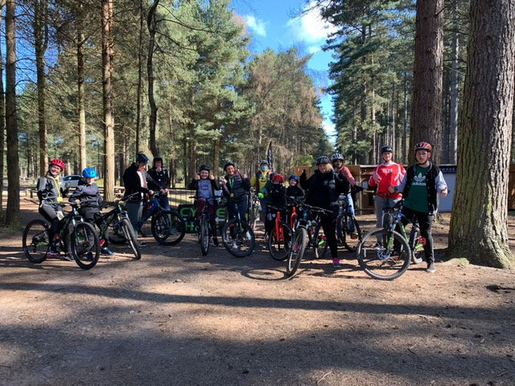

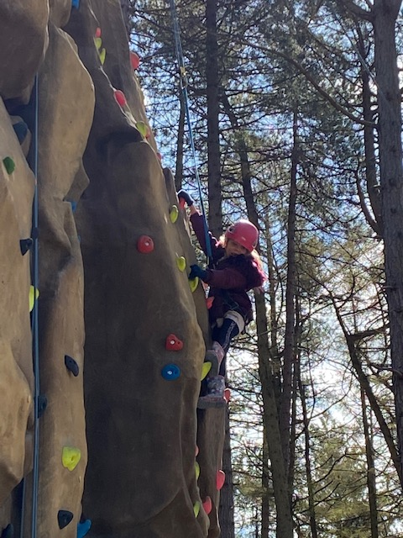

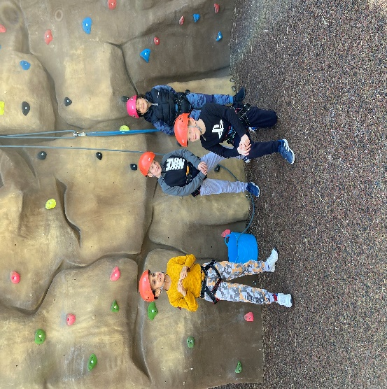

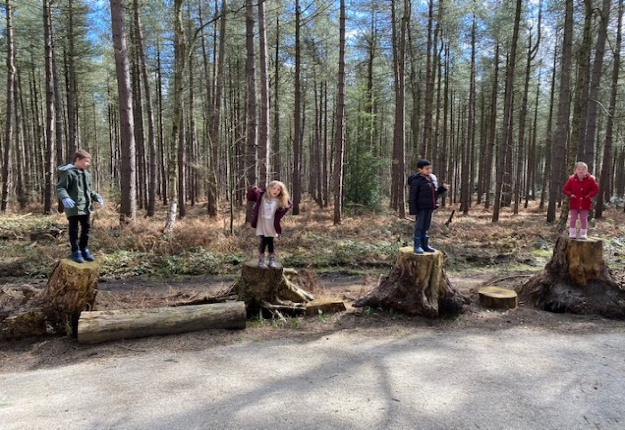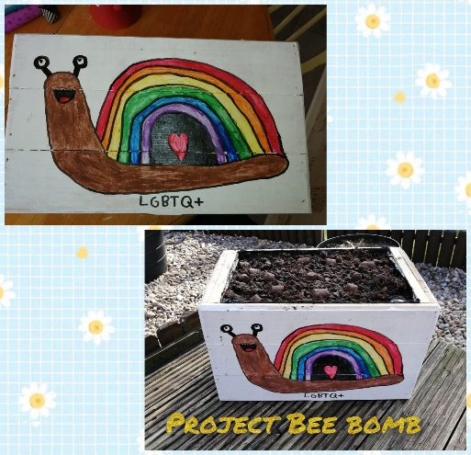

**PINE HOUSE IS STILL OPEN**

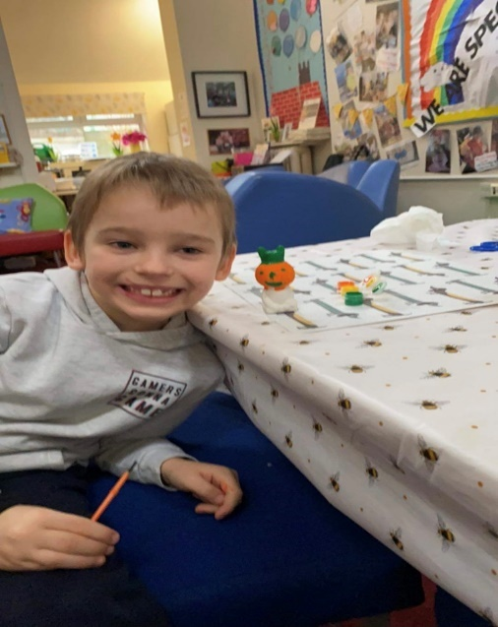Pine House Base -**Parent/Carer/Family Use** – **Free to use** Tuesday- Friday between 10am-5pm for one Family Household at a time to have ‘Family Time Out’ and ‘Home Schooling’ at our Wonderful base set in 70 Acres of Woodland - Please book your Morning/Afternoon/Weekend sessions in Advance as our base will need to be Deep Cleaned after every use by Emailing [info@spectrumwasp.org](mailto:info@spectrumwasp.org)

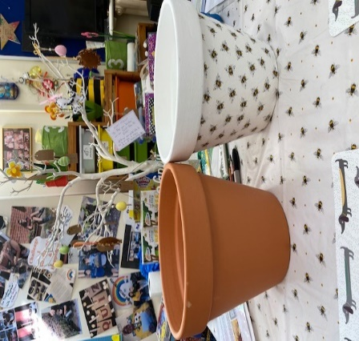**Support Worker**/Short Breaks Children/Young People for use Tuesday-Sunday - Please book your Morning/Afternoon/Weekend session in Advance, as our base will need to be Deep Cleaned after every use.

Enjoy Arts/Craft Materials… Woodland Nature Walk... Homework Catch up – Laptop/I-Pad/Eco Tank Colour Printer for your use with Home Schooling…Board Games ...Cake Baking Kits & Art Kits…TV/Netflix Films … OR Borrow our Spectrum WASP i-PAD with Parental/Carer Consent for Homework/School Work... Bring a Pack Lunch/Picnic to enjoy!

We provide Hot/Cold Drinks/Snacks to enjoy and Make/Cook yourself at the Base for free!

**Cycle Hire @ Sherwood Pines**…

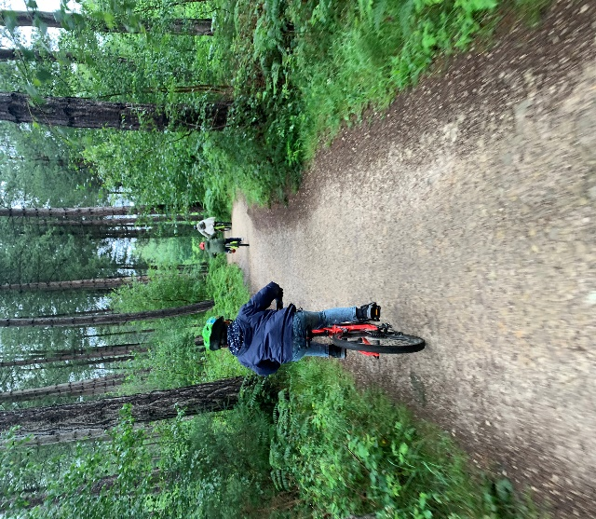We have been Cycle active throughout last year 2020, and now from April 2021 with Our Spectrum/Wasp **Free** **Cycle Hire** we are back again @ Sherwood Pines Cycle’s... Dan and the Team there, have given us Amazing Support over the last year, helping to look after our Registered Families and making sure every Bike is Checked/Sanitised, also providing a Safety Helmet if needed, it has been just wonderful… So go down and enjoy ‘Family Time Out’ and say ‘Hello to Dan/Team’ who are doing a brilliant job for us…🚴🏻‍♂️...

We again have been able to offer this to all of our Registered Families and Support Workers with our Short Breaks Children Teens/Siblings through ‘Children in Need’ Funding and The National Lottery Community Fund, ‘**THANK YOU’ to** everyone who has, and is still giving us Fantastic Support to carry on with our ‘Family Activities’.

Enjoy a 1hr bike ride Monday to Sunday at Sherwood Pines Cycle Shop on Site at the Pines. Children/Young People/Parents/Carers/Support Workers – No voucher needed for our **Spectrum WASP** **Registered Families**, head to Sherwood Pines Cycles and sign in on the Register with Dan & Staff... Enjoy the outdoor space on the Green Trail…Parents/Carers will take full responsibility for all Children/Young People while out on their Bikes. No Child/Young Person/Sibling is to Ride without Parent/Carer Support. (Cycle Shop is Open for Buying Cycles/Equipment/Maintenance/Service)

**How To Book Pine House A**



You will need to contact Sue or Jeni at [info@spectrumwasp.org](mailto:info@spectrumwasp.org) to book in ‘Our Diary’ your Morning/Afternoon or Weekend Session at Pine House for your ‘One Family Bubble’/Carer Session or for Support/Workers with Short Breaks (Respite Care) Children/Young Person’s wanting to use ‘Pine House A’ this will need to be booked in Advance in ‘Our Diary’…Thank You..

**Don’t forget to Keep ‘POSTING YOUR PHOTOS/VIDEOS’ to myself and Jeni so that we can Share with everyone at Spectrum/Wasp on our Website/Facebook Page … This all goes towards supporting our Evidence for Funding and most of All ‘Keeps Us All in Touch’ with each other... See you All soon…Take Care, Look after Each Other…**

**NOTE -: Due to Government Guidelines we are unable to issue Our Free Vouchers out, but we can add you to our Register to Post Out/Collect as soon as the Lockdown Restrictions are lifted. We can though at present offer the Use of Our Base at ‘Pine House A’ throughout the Week/Weekend and also McDonalds Meal Vouchers at the ‘Drive Thru’ @ Kingsmill Road East, NG17 7JP, Posting Out to You…Sue and Jeni are here to support you in anyway we can, just contact us…@** [**info@spectrumwasp.org**](mailto:info@spectrumwasp.org) **and we will get back to you.**

Spectrum WASP would like to say a BIG **Thank You** for the support that we have received from our Funders throughout the Coronavirus Pandemic (Covid-19). This has enabled us to continue to work and “**Keep in Touch”** with all our Children/Young People/Siblings and Families during these very unprecedented times…Sue & Jeni…. Registered Children’s Charity No 1146664… [www.spectrumwasp.org](http://www.spectrumwasp.org)

**Dates For The Diary – April/May/June 2021**

**April 202****1**

**Monday April 26th** – Parent/Carers **Coffee Morning 9.30-11.30am** @ Pine House A – Book a 1-1 Meeting due to G/Guidelines... if you would like to speak with Sue/Jeni/Victoria Confidentially

**Friday April 30th - Teen Club 11-18yrs –** Gymstarz Session with Gareth/Team on site @ Ransom Wood, Mansfield, NG21 0HJ. Our own Gymnastic Session, Air track, Beams, Bars, Games, Sensory Balls, Rebound, Springboard, Trampolining, ‘New Techno Gym Area’.. Meeting there @ 4.45am to start @ 5.00-6.30pm …Please wear Suitable Clothing .. Remember your Drinks Bottle ..Contribution is £3.00 per Young Person/Parents/Carers Welcome to Attend/Support.

**MAY**

**Monday May 3rd – Bank Hols – NO Coffee Morning**

**Wednesday May 5th …’Teens Club 11-18yrs’** **BIKE RIDE @ Sherwood Pine, Ollerton Rd, NG21 9JL** with Sue/Jeni/Ian … We can Hire/Bikes/Helmets for you from the Sherwood Cycle Hire on Site with Dan/Team or you can bring along you Own Bike/Helmet, we will be Meeting outside Sherwood Pines Café for 4.45pm for our ‘Teens Bike Ride’ to start at 5.00–6.30pm.. Parent/Carers Welcome to Support on the Bike Ride, … Please remember to bring your Drinks Bottle/ Picnic Snack for after if you would like to stay on for half an hour…Please Register if you would like to come along…This will be a **Free Session** for All Teen’s Riding….Please Book your Place so we can look out for you coming.

**Friday May 7th** – **JUNIOR GYM SESSION FOR ALL 5-10yrs**.@ ‘Gymstarz’ with Gareth/Team on Site @ Ransom Wood, Mansfield, NG21 0HJ. Our Own Gymnastic Session, Airtrack, Beams, Bars, Games, Sensory Balls, Rebound, Springboard, Trampolining. Meeting @ 4.45pm to Start @ 5.00-6.30pm Please wear suitable Clothing/Socks, Remember your Drinks Bottle.. Contribution is £3.00 per Child. Parents/Carers Welcome to Attend/Support.

**Monday May 10th** – Parents/Carers **Coffee Morning 9.30-11.30am** @Pine House A, Ransom Wood, Mansfield NG21 0HJ…Pop in for Coffee/Tea/Biscuit for a Catch up/Chat between 9.30-11.30am Victoria will be on hand on the day ..if you need to speak with either Victoria/Sue/Jeni Confidentially for a 1-1 Meeting please Book in Advance due to following Government Guidelines..

**Wednesday May 12th** - **NEW ENQUIRIES ‘PARENTS/CARERS MEETING’**- Presentation by Sue/Jeni/Steering Group Committee @ The Elements Suite (Downstairs in Ransom Hall use Spectrum/Wasp Office Entrance to excess) on the Ground Floor – Meeting ‘NEW’ Parent/Carers who have made contact through email over Lockdown to Spectrum/Wasp (Invitation Only due to Numbers, following Government Guidelines) Meeting @6.45pm to Start prompt @ 7.00-8.30pm ..Tea/Coffee Provided…

**Friday May 14th -Teen’s Club 11-18yrs its ‘New’- ‘Teen’s Team Competition Golf Driving Range’ including Burger/Chips/Juice@ Ramsdale Park Golf Centre, Oxton Rd, Calverton, NG14 6NU, in their Newly Refurbished Outdoor Games Competition TV/Video Area, with Coaching, All of the equipment provided. Meeting there at 4.45pm to start prompt @ 5.00-7.00pm…Contribution £5.00 per young person, Parents/Carers Welcome to Attend/Support or enjoy a MEAL/Snack in the Lounge area overlooking the Greens to enjoy the golf.. Places need to be Booked in Advance at** [**info@spectrumwasp.org**](mailto:info@spectrumwasp.org) **please remember to book your Young Persons place**

**MAY**

**Monday May 17th** – Parents/Carers **Coffee Morning 9.30-11.30am** @Pine House A, Ransom Wood, Mansfield NG21 0HJ…Pop in for Coffee/Tea/Biscuit for a Catch up/Chat between 9.30-11.30am ..Victoria will be on hand on the day ..if you need to speak with either Victoria/Sue/Jeni Confidentially for a 1-1 Meeting please Book in Advance due to following Government Guidelines..

**Wednesday May 19th** -**AGM Meeting for our End of Year** ..Management Committee to Attend @ Pine House A, Ransom Wood, NG21 0HJ.. Arrive @ 6.45pm to start prompt @ 7.00-8.30pm .. All Welcome, ..Please let Spectrum/Wasp know your Attendance due to Numbers and Following Government Guidelines.. at [info@spectrumwasp.org](mailto:info@spectrumwasp.org)

**Friday May 21st** – **JUNIOR GYM SESSION FOR ALL 5-10yrs**.@ ‘Gymstarz’ with Gareth/Team on Site @ Ransom Wood, Mansfield, NG21 0HJ. Our Own Gymnastic Session, Air track, Beams, Bars, Games, Sensory Balls, Rebound, Springboard, Trampolining. Meeting there @ 4.45pm to Start 5.00-6.30pm Please wear suitable Clothing/Socks, ..Remember your Drinks Bottle.. Contribution is £3.00 per Child. Parents/Carers Welcome to Attend/Support…

**Friday May 21st ..Teen’s Club 11-18yrs ‘Pool/Pizza Night’ Out/About** @ The Towers, Botany Ave, Mansfield, NG18 5NG. Meeting there @ 4.45pm to Start at 5.00-7.00pm. All equipment will be provided, also Pizza/Chips/Juice Drink @6pm. Contribution on the night will be £5.00.. Parent/Carers Welcome to Attend/Support

**Sunday May 23rd - Monthly RECYCLING Collection @ Pine House A, Ransom Wood, Mansfield, NG21 0HJ ..Drop off your RECYCLING Between 9.30-11.30am…Ask Family/Friends to Support our Monthly Fundraising…All Funding goes towards our Spectrum/Wasp Activity Programme**

**Monday May 24th** – Parent/Carers Coffee Morning 9.30-11.30am @ Pine House A, Ransom Woods, Mansfield NG21 0HJ, Pop in for a Coffee/Tea/Biscuit for a Catch up/Chat between 9.30-11.30am.. Victoria will be on hand on the day.. if you need to speak either with Victoria/Sue/Jeni Confidentially for a 1-1 Meeting please Book in Advance due to Government Guidelines**..**

**Friday May 28th – ‘Teen’s Club 11-18yrs’…** Let’s Chill at Pine House and ‘Get together Tonight’.. We can Do Outdoor Games/Kite Flying etc..Enjoy ‘Time-Out’ @ Pine House and Catch Up with Suggestions/Ideas, Where you would like to Go, & Thing’s to do over this Year ? and maybe enjoy ‘Pizza Tonight together’…Meeting @ Pine House A, Ransom Wood, NG21 0HJ @ 6.00-8.00pm. Contribution £3.00 …See you there Sue/Jeni..Parents/Carers Welcome to Attend/Support.

**June**

**Monday June 7th** Parents/Carers **Coffee Morning 9.30-11.30am** @Pine House A, Ransom Wood, Mansfield NG21 0HJ…Pop in for Coffee/Tea/Biscuit for a Catch up/Chat between 9.30-11.30am Victoria will be on hand on the day ..if you need to speak with either Victoria/Sue/Jeni Confidentially for a 1-1 Meeting please Book in Advance due to following Government Guidelines..

**Friday June 11th** – **JUNIOR GYM SESSION FOR ALL 5-10yrs**.@ ‘Gymstarz’ with Gareth/Team on Site @ Ransom Wood, Mansfield, NG21 0HJ. Our Own Gymnastic Session, Air track, Beams, Bars, Games, Sensory Balls, Rebound, Springboard, Trampolining. Meeting 4.45am to Start Prompt 5.00-6.30pm Please wear suitable Clothing/Socks, ..Remember your Drinks Bottle.. Contribution is £3.00 per Child. Parents/Carers Welcome to Attend/Support…

**MAY BANK HOILDAY - SCHOOL BREAKS UP FOR A WEEK**

**Tuesday June 1st – Archery/Woodland Assault Course for All Children Young People/Siblings …**  @ Lockwell Hill Activity Centre, Kirklington Rd, A617 Farnsfield, NG22 8JG, with Simon/Team ..Meeting there @ 9.45am to start prompt @ 10.00-12noon Wear Suitable Clothing/Footwear for the Assault Course, Remember your Gloves and Drinks Bottle… Contribution will be £5.00 per Child. Parents Welcome to attend/Support….Limited Number on the day so you need to Book your Place in advance [through..info@spectrumwasp.org](mailto:through..info@spectrumwasp.org)

**Wednesday June 2nd ‘GYMSTARZ’ 2 Fun Gym Sessions for 5-10yrs & 11-18yrs Gymnastic Sessions FOR ALL Children/Young People/Siblings** .@ ‘Gymstarz’ with Gareth/Team on Site (as you enter the Park on the Left by the first roundabout) @ Ransom Wood, Mansfield, NG21 0HJ. Our Own Gymnastic Session, Air track, Beams, Bars, Games, Sensory Balls, Rebound, Springboard, Trampolining. Please wear suitable Clothing/Socks, ..Remember your Drinks Bottle.. Contribution is £3.00 per Child. Parents/Carers Welcome to Attend/Support…Meeting there for **Session 1 for 5-10yrs .@ 9.45am to Start Prompt @ 10.00-11.00am**….**Session 2 for 11-18yrs Meeting there 11.05am to start Prompt @ 11.15-12.15am…**

**Friday June 4th Odeon Cinema Mansfield - Autism Friendly Showing For ALL ‘NEW’ Film to be Confirmed Nearer the Date…For ALL Children/Young People/Siblings Parents/Carers…We are so excited to be going back to the Cinema! We will be having our OWN SCREENING for Spectrum/Wasp Families to enjoy Safely following updated Guidelines …Meeting there @ 9.15am for the Film to start Prompt @ 9.30am…Child/Young Persons Contribution is £3.00 ..Parents/Carers are Free .. Please remember your Drinks Bottle/Snack to enjoy…**



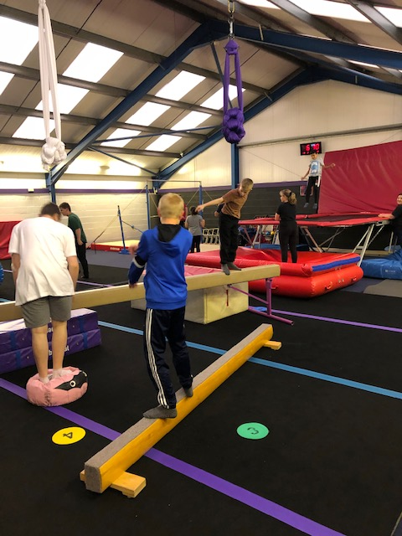

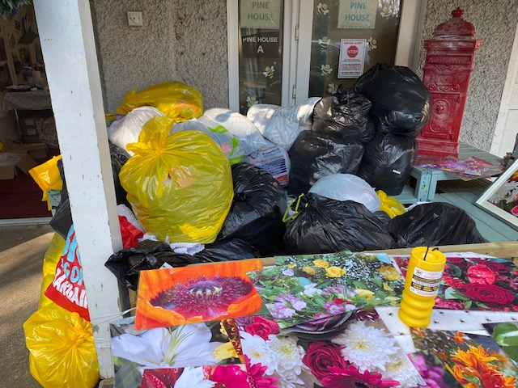**Sunday MAY 23rd … “RECYCLING COLLECTION” Drop Off at Pine House A, Ransom Wood, NG21 0HJ…9.30 – 11.30am…. Ask Family/Friends to support, if you need any of our Spectrum/Wasp Large Yellow Recycling Bags …we have them in Pine House for you to Collect from us or we can Post out if that helps….**



**APRIL 25th 2021 WE RAISED TOGETHER - £160.00**

**GUIDELINES - FOR ACTIVITIES FOLLOWING GOVERNMENT GUIDELINES**

**Note: - All our Activities will be following Government Guidelines/Social Distancing which can change on a day-to-day basis. Some Activities may be limited in numbers due to Guidelines, which will require Parents/Carers/Support Workers to prebook/ in advance via… info@spectrumwasp.org**

**ALL Activities are ‘Weather Permitting’ and we will be “KEEPING IN TOUCH” with our Registered Families by our Message Bird Text Service.**

**UP - COMING RECYCLING DATES – May 23rd June 27th, July 25th, September 19th**

**APRIL – EASTER NEWS**

**Heather our Chairperson, and Nicola our Deputy Chair both held Amazing ‘Easter Raffles’ for Spectrum/Wasp to support Fundraising for us. Heather held our ‘Easter Virtual Raffle’ which was drawn Live at our Base ‘Pine House ’on Good Friday April 2nd Where Six ‘Egg- clusive’ Fantastic Prizes were Won, Raising a ‘Fabulous £343.00’ …. Nicola who works for Lloyds Bank, Carlton Branch, who through the Bank/Customers/Team there, raised in Branch, with their ‘Easter Raffle’ Fundraising for us, a Fantastic £283.18, which Lloyds have Match Funded, doubling the amount raised, it has been such a wonderful Fundraising Easter for Spectrum/Wasp, ‘THANK YOU’ to Everyone who Supported and brought Tickets for Easter.**

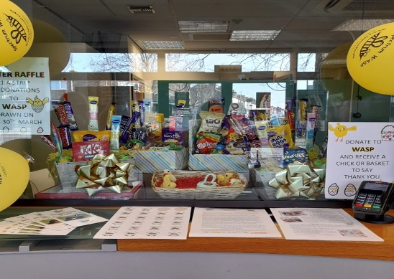 **Connor is Holding his ‘Design an Easter Egg Competition’ with Spectrum/Wasp…ALL Children/Young People that entered we felt were All Winners so you will ALL be receiving a ‘McDonalds’ Voucher in the Post..as a Treat to enjoy, ‘Thank You’ for your Fantastic Creative Designs, that we have put around our Information Board at Pine House for All to see and enjoy …**

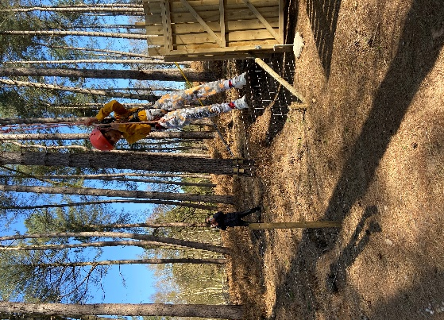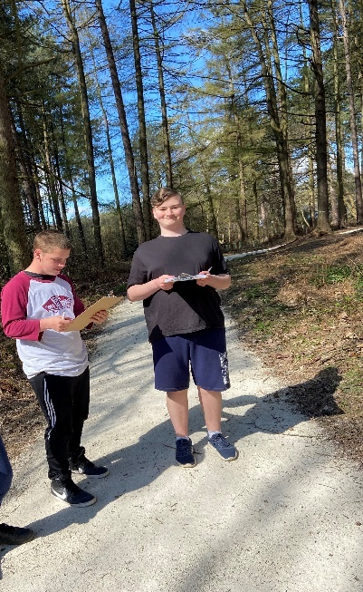**PORTLAND COLLEGE ‘ADVENTURE ZONE’ AT EASTER WAS JUST AMAZING FUN FOR SPECTRUM/WASP!!**

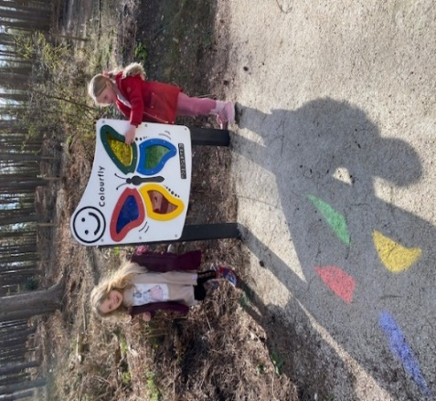**We just think the ‘Adventure Zone’ at Portland College is Great, every time we go, we just see and learn lots more, Thanks to Great Instructors Becca, Phil, and Lee, it’s such an Adventure there of Fun/Smiles. At Easter we did Woodland Orienteering, Wall Climbing & Zip Wire**