

**Spectrum WASP Newsletter**

**March/April 2021**

 SPRING HAS SPRUNG @ SPECTRUM/WASP … EASTER IS ON THE WAY!!

Here at Spectrum/Wasp we are planning some wonderful Easter Fun Activities for ALL to get involved in…So keep an Eye out for that ‘EGG..STATIC’ Easter News’ ..it’s going to be an ‘Egg..cellent’ Time for us All..

We hope All our Children, Young People and Siblings will bring out their Creative ideas in getting involved with ‘Poetry’ For ALL, with Alan Dawson, Our Decorating Planters/Pots Competition, Easter Raffle Fundraiser with Heather, Family Friday Bingo for Comic Relief and our Super Easter ‘Drive By’ at Pine House on Good Friday to Collect your next ‘Four Season Challenge’ ...What’s that l here you say?... It’s so Exciting for Myself and Jeni to be looking forward to planning this year’s Adventures at Spectrum/Wasp as Lockdown Restrictions start to ease… We hope to be Sharing some wonderful news soon through our Activity Programme, Teen’s Club, going Out/About…and Working in Partnership through …Children in Need with our ‘Pudsey Parcel’?... Clue ‘DFS’…

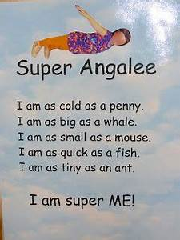**Made in Mansfield Poetry**

#madeinmansfield is a local poetry initiative which encourages positive writing and is aimed at showcasing all that is good about the Mansfield and Ashfield area.

What is better about the area than the Spectrum Wasp? It would be great if you could write some poetry as a celebration of the Wasps – or draw pictures…tell a story or whatever way you wish to express yourselves. This is open to ALL Children, Y/People, Siblings.

You could write about:

* Activities/ visits
* Friends
* Fun and lots more.

Do not worry what the poetry looks like, I can support your writing if you wish – it does not have to rhyme it can be how you want it and written on whatever. It can be funny, serious, true, made up etc.

I am at [townsman@hotmail.com](mailto:townsman@hotmail.com) if you would like any support or wish to send me a poem.

All Poetry sent through to Spectrum/Wasp for Alan Dawson will receive a... ‘MC DONALDS

VOUCHER’ treat to enjoy…so Let us All start our Creative Writing/Poetry or Drawings for Alan over Easter. At Spectrum/Wasp All Creative Writing/Poetry/Drawings will be Displayed within our Base at Pine House for All to see and enjoy… [info@spectrumwasp.org](mailto:info@spectrumwasp.org)

**PINE HOUSE IS STILL OPEN**

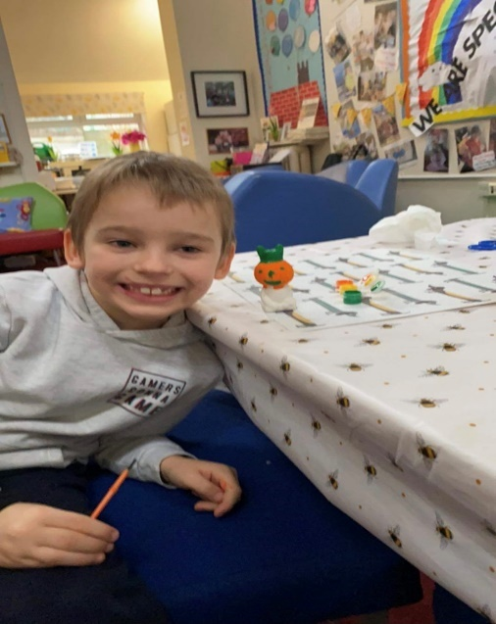Pine House Base -**Parent/Carer/Family Use** – **Free to use** Tuesday- Friday between 10am-5pm for one Family Household at a time to have ‘Family Time Out’ and ‘Home Schooling’ at our Wonderful base set in 70 Acres of Woodland - Please book your Morning/Afternoon/Weekend sessions in Advance as our base will need to be Deep Cleaned after every use by Emailing [info@spectrumwasp.org](mailto:info@spectrumwasp.org)

**Support Worker**/Short Breaks Children/Young People for use Tuesday-Sunday - Please book your Morning/Afternoon/Weekend session in Advance, as our base will need to be Deep Cleaned after every use.

Enjoy Arts/Craft Materials… Woodland Nature Walk... Homework Catch up – Laptop/I-Pad/Eco Tank Colour Printer for your use…Board Games ...Baking Kits & Art Kits…TV/Netflix Films … OR Borrow our Spectrum WASP i-PAD with Parental/Carer Consent for Homework/School Work... Bring a Pack Lunch/Picnic to enjoy!

We provide Hot/Cold Drinks/Snacks to enjoy and Make/Cook yourself at the Base for free!

**Cycle Hire @ Sherwood Pines**…

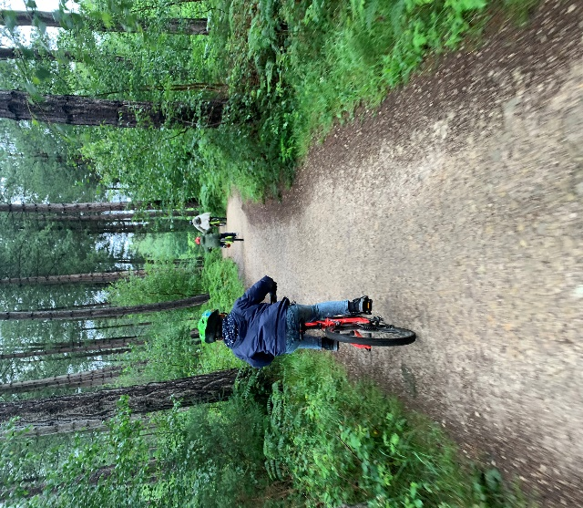We have been Cycle active throughout last year 2020, and now from April 2021 with Our Spectrum/Wasp **Free** **Cycle Hire** we are back again @ Sherwood Pines Cycle’s... Dan and the Team there have given us Amazing Support, helping to look after our Registered Families and making sure every Bike is Checked/Sanitised, also providing a Safety Helmet if needed, it has been just wonderful… So go down and enjoy ‘Family Time Out’ and say ‘Hello to Dan/Team’ who are doing a brilliant job for us…🚴🏻‍♂️...

We again have been able to offer this to all of our Registered Families and Support Workers with our Short Breaks Children Teens/Siblings through ‘Children in Need’, and The National Lottery Community Fund, ‘**THANK YOU’** everyone who has, and is still giving us Fantastic Support to carry on with our ‘Family Activities’.

Enjoy a 1hr bike ride Monday to Sunday at Sherwood Pines Cycle Shop on Site at the Pines. Children/Young People/Parents/Carers/Support Workers – No voucher needed for our **Spectrum WASP** **Registered Families**, head to Sherwood Pines Cycles and sign in on the Register with Dan & Staff... Enjoy the outdoor space on the Green Trail…Parents/Carers will take full responsibility for all Children/Young People while out on their Bikes. No Child/Young Person/Sibling is to Ride without Parent/Carer Support. (Cycle Shop is Open for Buying Cycles/Equipment/Maintenance/Service)

**How To Book Pine House A**

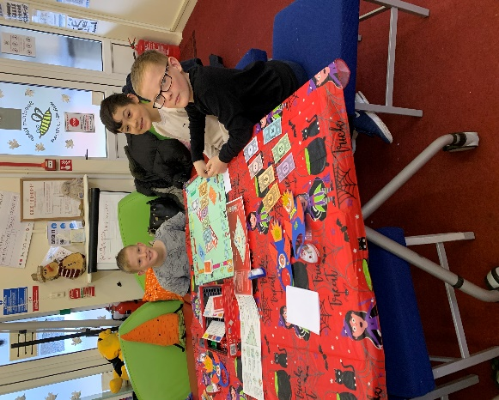You will need to contact Sue or Jeni at [info@spectrumwasp.org](mailto:info@spectrumwasp.org) to book in ‘Our Diary’ your Morning/Afternoon or Weekend Session at Pine House for your ‘One Family’/Carer Session or for Support/Workers with Short Breaks (Respite Care) Children/Young Person’s wanting to use ‘Pine House A’ this will need to be booked in Advance in ‘Our Diary’…Thank You..

**Don’t forget to Keep ‘POSTING YOUR PHOTOS/VIDEOS’ to myself and Jeni so that we can Share with everyone at Spectrum/Wasp on our Website/Facebook Page … This all goes towards supporting our Evidence for Funding and most of All ‘Keeps Us All in Touch’ with each other... See you All soon…Take Care, Look after Each Other…**

**NOTE -: Due to Government Guidelines we are unable to issue Our Free Vouchers out, but we can add you to our Register to Post Out/Collect as soon as the Lockdown Restrictions are lifted. We can though at present offer the Use of Our Base at ‘Pine House A’ throughout the Week/Weekend and also McDonalds Meal Vouchers at the ‘Drive Thru’ @ Kingsmill Road East, NG17 7JP, Posting Out to You…Sue and Jeni are here to support you in anyway we can, just contact us…@** [**info@spectrumwasp.org**](mailto:info@spectrumwasp.org) **and we will get back to you.**

Spectrum WASP would like to say a BIG **Thank You** for the support that we have received from our Funders throughout the Coronavirus Pandemic (Covid-19). This has enabled us to continue to work and “**Keep in Touch”** with all our Children/Young People/Siblings and Families during these very unprecedented times…Sue & Jeni…. Registered Children’s Charity No 1146664… [www.spectrumwasp.org](http://www.spectrumwasp.org)

**Diary Dates & News**

**Dates For The Diary – March/April 2021**

**March 202****1**

**Monday 15th March** – Parent/Carers Coffee Morning 9.30-11.30am @ Pine House A – Book a 1-1 Meeting due to G/Guidelines... if you would like to speak with Sue/Jeni/Victoria Confidentially

**Wednesday 17th March…** `Steering Group Meeting` @ Pine House A & Via Zoom ... @ 7.00-8.30pm

**Friday 19th March @ 7:00pm ‘EYES DOWN’.. ‘5 Games of 1 or 2 Lines of ‘Family BINGO at Home’ Great Family Night in with Prizes to Win!!! ..It’s Spectrum WASP with Sue/Jeni ‘Live’ @ 7.00pm ..@Pine House A, with our Super Special Fundraiser for ’COMIC RELIEF 2021’ …‘`…**

**Head over to our Spectrum/Wasp Facebook page and Join in on Friday March 19th @ 7pm… Your Bingo Book is Enclosed with your Newsletter for our Family Fundraiser for Comic Relief 2021!! .. Just a Small DONATION to Play via our Spectrum/Wasp - Pay/Pal A/C under Family/Friends.. Please Register your Donation in Advance of ‘ FRIDAY BINGO ’ ..This Week March 19th @7.00pm**

**Sunday 21st** **March…’**Teens Club 11-18yrs’ **BIKE RIDE** with Ray/Jeni/Ian (All attending need to bring along their **OWN BIKES/Helmets** on the day (Due to the Cycle Shop not hiring out until April) Meeting @Sherwood Pines ..Meet outside Sherwood Pines Café for 10.15am for our ‘Family Bike Ride’ to start at 10.30–12.00 noon.. Parent/Carers Welcome to Support on the Bike Ride, … Please remember to bring your Drinks Bottle/Snack…Please Register if you would like to come along.

**Monday 22nd March..** Parent/Carers Coffee Morning 9.30-11.30am @ Pine House A – Book a 1-1 Meeting due to G/Guidelines.. if you would like to speak with Sue/Jeni/Victoria Confidentially

**Sunday 28th March – Monthly RECYCLING Collection @ Pine House A, Ransom Wood, Mansfield, NG21 0HJ ..Drop off your RECYCLING Between 9.30-11.30am…Ask Family/Friends to Support our Monthly Fundraising…**

**Monday 29th March** Parent/Carers Coffee Morning 9.30-11.30am @ Pine House A – Book a 1-1 Meeting due to G/Guidelines.. if you would like to speak with Sue/Jeni/Victoria Confidentially

**APRIL 2021 – EASTER HOLIDAY ACTIVITIES START @ SPECTRUM/WASP**

**Good Friday 2nd April** – It’s All Happening this Morning with our **Easter Raffle Draw** Taking Place **Live** **Today** with Heather and her Boys Liam/Brad @ **Pine House at 9.00am**…So you can have your Prize in time for Easter…

**Good Friday – 2nd April – Easter Starts today for us @ Spectrum/Wasp – Call By @ Pine House A, Ransom Wood, NG21 0HJ, to Collect your Easter Surprise Treats… We have a Mega Morning Easter ‘EGG-STRAVANZA’ with Sue/Jeni/Ian to Collect Your Next ‘Four Season Project’.. You’ll need a Big Car Boot for this one, it’s our Biggest Fun Fabulous Challenge Collection to Date…for All the Family to Take Part in… ‘Seed, Sow, Grow’..Planters/Plant Pots to Decorate, ‘Beebombs Wildflowers’ ’Seed Pantry Eco Boxes’ with Full instructions, something for All the Family to take part in ..We are ‘Blooming’ at Spectrum/Wasp with a Rainbow of Colours… Not forgetting your Easter Treats also to Collect… Collect on Friday between 9.30-11.30am…we’ll be waiting for you ..Sue/Jeni/Ian…**

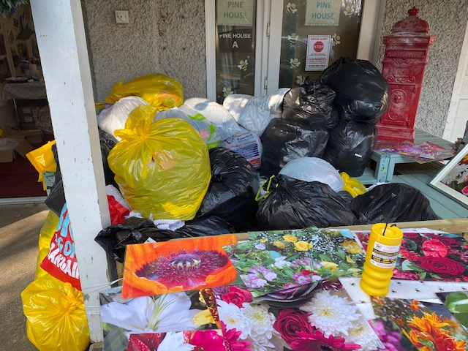**Sunday 28th March … “RECYCLING COLLECTION” Drop Off at Pine House A, Ransom Wood, NG21 0HJ…9.30 – 11.30am…. Ask Family/Friends to support, if you need any of our Spectrum/Wasp Large Yellow Recycling Bags …we have them in Pine House for you to Collect from us or we can Post out if that helps….**



**GUIDELINES - FOR ACTIVITIES FOLLOWING GOVERNMENT GUIDELINES**

**Note: - All our Activities will be following Government Guidelines/Social Distancing which can change on a day-to-day basis. Some Activities may be limited in numbers due to Guidelines, which will require Parents/Carers/Support Workers to prebook/ in advance via… info@spectrumwasp.org**

**ALL Activities are “Weather Permitting” and we will be “KEEPING IN TOUCH” with our Registered Families by our Message Bird Text Service.**

**DATES FOR THE DIARY APRIL 2021**

**Heather our Chairperson, will be holding our ‘Easter Virtual Raffle’ again for us this year as our ‘Easter Fundraiser’…With Six ‘Egg- clusive’ Fantastic Prizes to be Won in time for Easter… It’s Just £1.00 for a strip of 5 Tickets… ‘BARGAIN!!!... So help support our Easter Fundraiser, by asking Family Friends and Work Colleagues to support Spectrum/Wasp Easter Fundraiser.. Tickets can be brought now by Contacting Heather by Text Only on 07730373033, who will send a Text copy of your Tickets to you. The Draw will take Place Live on our FaceBook Page on Good Friday April 2nd @ 9.00am with Heather and her Boys Liam/Brad, Just in time for the Easter Bunny Calling … Pay for All Tickets through our Spectrum/Wasp ‘Pay-Pal A/C using the Option ‘Family/Friends’**

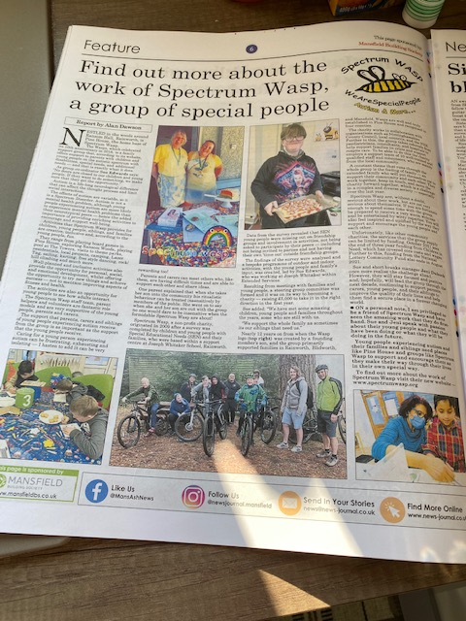**We want to ‘Thank’ Alan Dawson (Playwright/Journalist) Who has written this Months (March) Feature Full Page Article in the ‘News Journal’ Free Paper in (Mansfield, Ashfield, Warsop) which can be found in Tesco and most Supermarkets, Post Offices, Newsagents, etc…it is the most wonderful read…Please take time to find out more about us, and what we’ve been up too…we do have some copies in our Base at Pine House..Let your Family/Friends know… it’s just ‘Fabulous support for Spectrum/Wasp from Alan …**

**April 2nd - 2021 World Autism Awareness Day.. Week commencing March 29th – April 4th 2021**

**Good Friday April 2nd – Pine House will be Buzzing for Easter with Children/Families Collecting our ‘Seed, Sow, Grow’ Project, along with Heather LIVE on our FaceBook Page Drawing our Easter Raffle Fundraiser. Then in the Evening Alan Dawson’s Headstocks Theatre Group Live on Zoom showcasing ‘Marshmallow Sky’ for Autism Awareness Week for All Spectrum/Wasp Families to enjoy .. it’s an Amazing Play that was first performed at The Palace Theatre in 2013 which l was lucky enough to go and see…more info to follow…**