**Spectrum WASP Newsletter**

**January/February 2021**

**Bringing in Miles of Smiles with Spectrum/Wasp For 2021...**

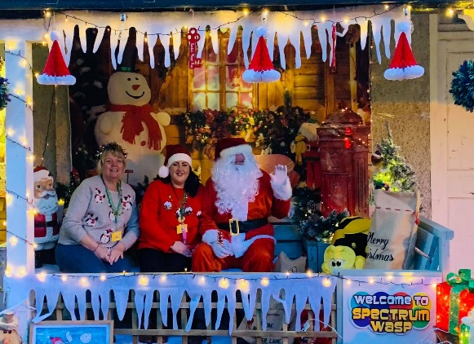**“Staying Positive Keeping in Touch**

**‘Happy 2021’…”**

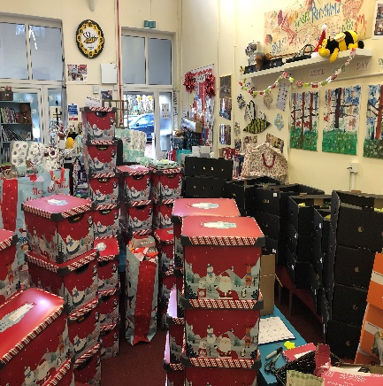Both myself, Jeni and Our Volunteer Team had the most ‘Wonderful Time’ with the run up to Christmas. We had our ‘Door Step Drop’ - Following Social Distancing, seeing the Surprise and Happiness that it brought to ALL our Children/Siblings/Young People and Families, made up for all the hard work to get to that point, so Rewarding! ... That same Day Our Special Visitor, ‘Santa’ called by on a Flying Visit to Pine House at Our ‘Outside’ Grotto, which you were All able to visit, this made for an Extra Special Day, where for a moment it was just ‘Magical’ …

“Let’s Stay Positive ...Thinking about all the Good things we are ALL going to Do together throughout 2021,.. Keeping in Touch”, Being Kind to each other and most of All having some Wonderful Fun Times & Smiles this year, is still our ‘Moto’ at Spectrum/Wasp for Everyone….

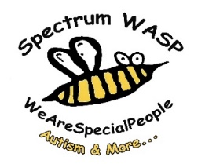Take Care Sue & Jeni

**PINE HOUSE IS STILL OPEN**

Pine House Base -**Parent/Carer/Family Use** – **Free to use** Monday- Friday between 10am-5pm for one Family Household at a time to have ‘Family Time Out’ and ‘Home Schooling’ at our Wonderful base set in 70 Acres of Woodland - Please book your Morning/Afternoon/Weekend sessions in Advance as our base will need to be Deep Cleaned after every use by Emailing [info@spectrumwasp.org](mailto:info@spectrumwasp.org)

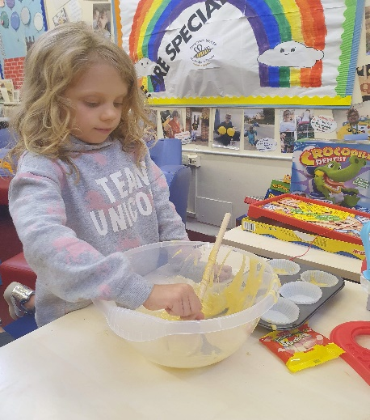**Support Worker**/Short Breaks Children/Young People for use Monday-Sunday - Please book your Morning/Afternoon/Weekend sessions in Advance as our base will need to be Deep Cleaned after every use.

Enjoy Arts/Craft Materials… Woodland Nature Walk... Homework Catch up – Laptop/I-Pad/Eco Tank Colour Printer for your use…Board Games ..Baking Kits & Art Kits…TV/Netflix Films … OR Borrow our Spectrum WASP i-PAD with Parental/Carer Consent for Homework/School Work... Bring a Pack Lunch/Picnic to enjoy!

We provide Hot/Cold Drinks/Snacks at the Base for free!

**Winter Activity Vouchers for January-February 2021**

Please see below a range of Activities we are offering out throughout January-February 2021 to Spectrum WASP Registered Families with Children/Young People/Siblings. (**When Venues Re-Open**)

**Please note:** These Activities will require a Parent/Carer or a Short Breaks Support Worker to participate with the Child/Young Person or Sibling throughout the Activity to take full responsibility during the session booked, following the latest ‘Up to Date’ Government Guidelines and Keeping Social Distance.



**Clip ‘n Climb Vouchers - Free**

1 Gift Voucher entitles each Child/Young Person to a 1hr obstacle Clip ‘n Climb session which provides healthy fun for everyone with over 20 different challenges to test your skills and resolve.

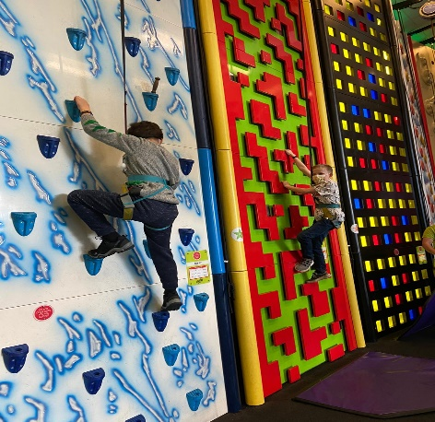All Covid-19 information will be sent out with your Gift Voucher.

Please call Clip ‘n Climb in Nottingham to pre book your session on 0115-8227120 before attending

How to find: Less than 2 miles from junction 26 of the M1 @ Millennium Way East, Phoenix Park, Nottingham NG8 6AR

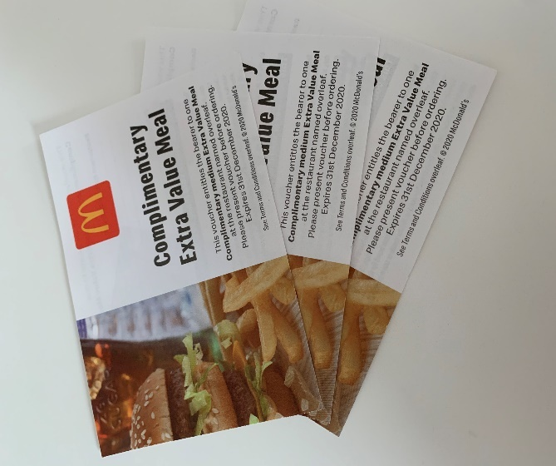**McDonalds “Treat” Meal Voucher - Free**

A special treat for each Spectrum WASP Child/Young Person/Sibling to enjoy an Extra Value Meal at our local McDonalds. Each Voucher can be redeemed for a Happy Meal or Extra Value Meal which will include Fries and a Drink

**Please Note: - Open at ‘Drive Through’**

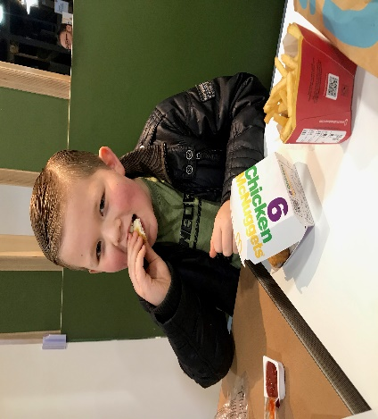**THE VOUCHER IS ONLY VALID FOR THE…KINGSMILL ROAD McDonalds RESTAURANT DRIVE THRU…**

How to find: Kings Mill Road East…Sutton in Ashfield…NG17 4JP

 **ODEON Mansfield Cinema Voucher - Free**

1 Cinema Gift Card entitles your Child/Young Person/Sibling to a £5 Childs Film or £5 off the Film of your choice when visiting the Odeon Cinema. How to Find: ODEON Mansfield, Park Lane, Mansfield NG18 1BU

**i-JUMP Trampoline Park Vouchers**

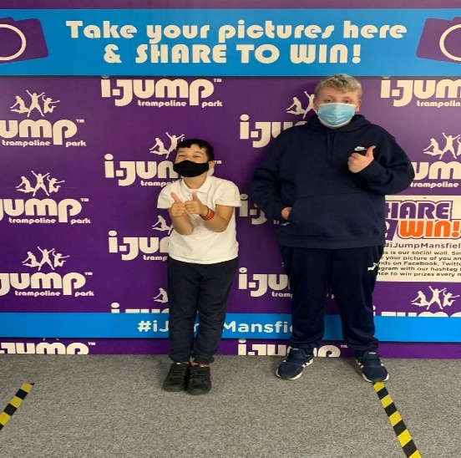1 Voucher entitles each Child/Young Person to a 1hr jump session @ i-Jump Mansfield NG19 9AL. Also enclosed within the voucher are the instructions to attend and COVID information guidance.

Please call 01623 705909 to book your session…You will need to complete a wavier form before the session online.

Spectrum WASP are providing Free vouchers for Our Spectrum/WASP Children/Young Person/Siblings & Registered Families through funding received from Children in Need, & The National Lottery Community Fund.

**Cycle Hire @ Sherwood Pines**…

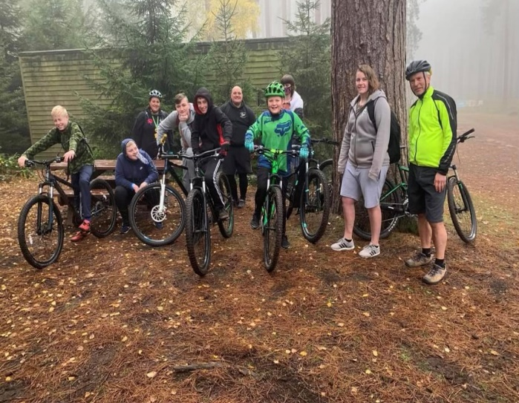We have been active through last Summer/Autumn and now Winter 2021 with Our Spectrum/Wasp **Free** **Cycle Hire** at Sherwood Pines Cycles...Dan and the Team there have given us Amazing Support Helping to look after our Registered Families and making sure every Bike is Checked/Sanitised, also providing a Safety Helmet if needed. It has been just wonderful…

So much so that this is still on going through January-February 2021…So go down and enjoy ‘Family Time Out’ and say ‘Hello to Dan/Team’ who are doing a brilliant job for us…🚴🏻‍♂️...(**Not Available during Lockdown**)

We again have been able to offer this to all of our Registered Families and Support Workers with our Short Breaks Children Teens/Siblings through ‘Children in Need’, and The National Lottery Community Fund, ‘**THANK YOU’** everyone who has, and is still giving us Fantastic Support to carry on with our ‘Family Activities’.

Enjoy a 1hr bike ride Monday to Sunday at Sherwood Pines Cycle Shop on Site at the Pines. Children/Young People/Parents/Carers/Support Workers – No voucher needed for our **Spectrum WASP** **Registered Families**, head to Sherwood Pines Cycles and sign in on the Register with Dan & Staff... Enjoy the outdoor space on the Green Trail…Parents/Carers will take full responsibility for all Children/Young People while out on their Bikes. No Child/Young Person/Sibling is to Ride without Parent/Carer Support. (Cycle Shop is Open for Buying Cycles/Equipment Only) **during Lockdown**

**Diary Dates & News**

**‘Negwitch and Poswitch’ via Zoom With Alan Dawson This FRIDAY**

Alan Dawson, Playwright/Friend to Spectrum/Wasp through our ‘Teen’s Club’, has personally invited All our Teens/Children/Families to join his Quest with ‘Negwitch & Poswitch’ this Friday Evening January 15th @ 7.00pm via Zoom… Watch out this week for your MessageBird Message with details on how to join in with our ‘Fun Family Social Night In’ via Zoom

“I am an intrepid journalist looking for positive news – I need your help, I am being pursued by *Negwitch* who is trying to stop me… see you soon on the **January 15th @ 7.00pm** on Zoom**\***, be prepared for battle, for you must save me from *Negwitch*…”

After we have defeated Negwitch only then can we discuss the #madeinmansfield poetry initiative…

Stay positive.

Alan Dawson, the second most popular writer in Mansfield.

**‘Family Night In’ - with Spectrum/Wasp Quiz Night**

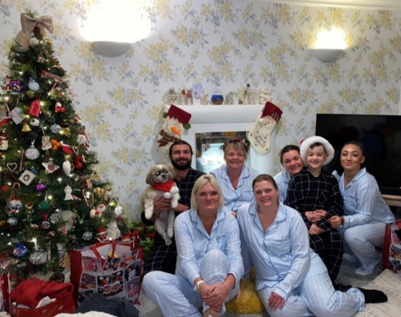

Join our Friday Night Family Fun Quiz’s…

All Children/Families can join us from the comfort of their own home ‘Keeping Safe’ via our Facebook Live

Join Sue and Family on Friday 29th January @ 7.00pm

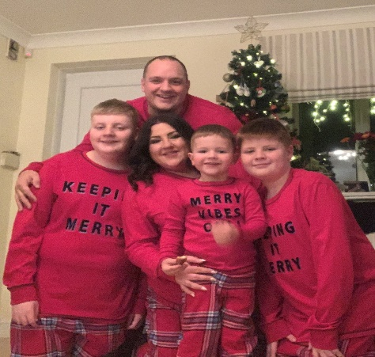Pre-Valentine Quiz with Jeni and Family on Friday February 12th @ 7.00pm

**How To Book Our ‘Free Vouchers or Pine House A**

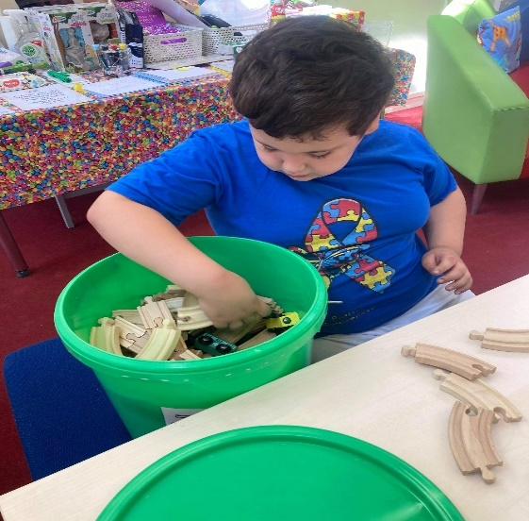

You will need to contact Sue or Jeni at [info@spectrumwasp.org](mailto:info@spectrumwasp.org) to arrange a Collection/Postal for your Child/Young Person/Sibling’s Free Vouchers for Jan/Feb 2021 …or to book in ‘Our Diary’ your Morning/Afternoon or Weekend Session at Pine House for your ‘One Family’/Carer Session or for Support/Workers with Short Breaks (Respite Care) Children/Young Person’s wanting to use ‘Pine House A’ this will need to be booked in Advance in ‘Our Diary’…Thank You..

**Don’t forget to Keep ‘POSTING YOUR PHOTOS/VIDEOS’ to myself and Jeni so that we can Share with everyone at Spectrum/Wasp on our Website/Facebook Page … This all goes towards supporting our Evidence for Funding and most of All ‘Keeps Us All in Touch’ with each other... See you All soon…Take Care, Look after Each Other…**

**NOTE -: Due to Government Guidelines we are unable to issue Our Free Vouchers out, but we can add you to our Register to Post Out/Collect as soon as the Lockdown Restrictions are lifted. We can though at present offer the Use of Our Base at ‘Pine House A’ throughout the Week/Weekend and also McDonalds Meal Vouchers at the ‘Drive Thru’ @ Kingsmill Road East, NG17 7JP, Posting Out to You…Myself and Jeni are here to support you in anyway we can, just contact us…@** [**info@spectrumwasp.org**](mailto:info@spectrumwasp.org) **and we will get back to you.**

Spectrum WASP would like to say a BIG **Thank You** for the support that we have received from our Funders throughout the Coronavirus Pandemic (Covid-19). This has enabled us to continue to work and “**Keep in Touch”** with all our Children/Young People/Siblings and Families during these very unprecedented times…Sue & Jeni…. Registered Children’s Charity No 1146664… [www.spectrumwasp.org](http://www.spectrumwasp.org)

**Diary Dates & News**

**Dates For The Diary November – December 2020**

**November 2020**

**Sunday 8th November…** `Teens Club 11-18yrs’ Bike Ride with Ray/Jeni @ Sherwood Pines ..Meeting outside Sherwood Pines Cafe. Meeting 10.15 for our Family Bike Ride to start at 10.30–12.00noon.. Parent/Carers Welcome to Support on the Bike Ride, Please remember to bring your Drink Bottle/Snack

**Monday 9th November** – Parent/Carers Coffee Morning 9.30-11.30am @ Pine House A – Book a 1-1 Meeting due to G/Guidelines.. if you would like to speak with myself/Jeni confidentially

**Wednesday 11th November…** `Steering Group` Zoom Meeting Held by Heather (Chair Person).. 7.00-8.30pm Parents/Carers Welcome to attend via Zoom Please let Heather know so we can send over to you the Link.. via Zoom on the night

**Friday 13th November @ 7:00PM… ‘EYES DOWN’ - ‘5 Games of Full House Family Bingo at Home’ Great Family Night in with Prizes to Win!!! It’s Spectrum WASP with Sue/Jeni ‘Live’ from Pine House A, with our Super Special Fundraiser for ’BBC Children in Need Night’ …‘Together We Can`…**

**Head over to our Facebook page and Join in and have some fun… Your Bingo Book will come in with your Postal Drop this Week…along with all the information you need for our Family Fundraiser with Children in Need 2020!!**

**Monday 16th November…** `Coffee Morning’ 9.30-11.30am @ Pine House – Book a 1-1 Meeting due to Government Guidelines – if you would like to catch up with Jeni or l …

**Friday 20th November****…** `Gymstarz/Gymnastics Junior Session 5-10yrs` … Air track, Beams, Bars, Sensory Equipment with Gareth/team at their Base on site at Ransom Wood, NG21 0HJ… Meeting there @ 5.30–7.00pm Parent/Carer Welcome to attend… Remember to bring your drinks bottle – Now **CANCELLED** due to Following Government Guidelines until after December 3rd 2020 which will then be revised .. Gareth can arrange a 30min or 45mins ‘One Family Only Session’…you will need to contact him direct and email Gymstarz for Price/Date/Times

**Friday 25th November … Wednesday Steering Group/Parents Meeting Zoom at 7.00pm before Christmas….and Virtual ’12 Days of Christmas Raffle’ being discussed with Draw to take place in December before Christmas so you can enjoy your Prize .. Tickets Now Available through Heather.. Payment Via PayPal Family/Friends ‘Meeting through ‘Zoom’… Please let us know if you if you would like the ‘Zoom Link’ sending to you, to join our Meeting via our** [**info@spectrumwasp.org**](mailto:info@spectrumwasp.org) **or text**

**Friday 27th November …**`Gymstarz/Gymnastics Teens Session 11-18yrs… Air track, Beams, Bars, Sensory Equipment with Gareth/team at their Base on site at Ransom Wood, NG21 0HJ… Meeting there @ 5.30–7.00pm Parent/Carer Welcome to attend… Remember to bring your drinks bottle – Now **CANCELLED** due to Following Government Guidelines until after December 3rd 2020 which will then be revised .. Gareth can arrange a 30min or 45mins ‘One Family Only Session’…you will need to contact him direct and email Gymstarz for Price/Date/Times

**DECEMBER 2020**

**Sunday 6th December … “RECYCLING COLLECTION” Drop Off at Pine House A, Ransom Wood, NG21 0HJ. The last one before Christmas…Drop 10.00-12noon…. Ask Family/Friends to support, if you need any of our Spectrum/Wasp Large Yellow Recycling Bags …we have them in Pine House for you to Collect from us or we can Post out if that helps….**



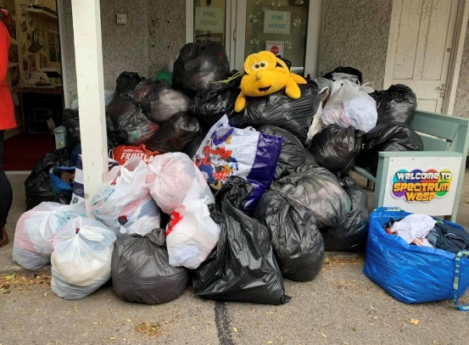

**GUIDELINES - FOR ACTIVITIES FOLLOWING GOVERNMENT GUIDELINES**

**Note: - All our Activities will be following Government Guidelines/Social Distancing which can change on a day-to-day basis. Some Activities may be limited in numbers due to Guidelines, which will require Parents/Carers/Support Workers to prebook/ in advance via… info@spectrumwasp.org**

**ALL Activities are “Weather Permitting” and we will be “KEEPING IN TOUCH” with our Registered Families by our Message Bird Text Service.**